Assignment 2
5110309783 陈宇翔

P1
Dining philosophers problem

To solve this problem, I need to specify the eating time and the time segment for each philosopher to try to get the forks. In the program, I define them as MAX_EAT_TIME and TRYING_SEGMENTS, you can change them in the definition part of the program.
The other parts of this problem is quite easy, by using pthread. I use five threads to present the five philosophers, and use an integer array to present the forks between them. By letting the five threads run together, we can simulate the five philosophers who wants to eat. Each thread will try to get the forks, if they cannot get both of them, they will try it later in a random time. And they can only begin eating if they have access to both forks, which are projected to the array.
The following is the picture of the compiling part. To get the serial number of each thread, I pass the number in the pthread_create function. And here are some warnings about this part, however, they do not have influence on this problem.
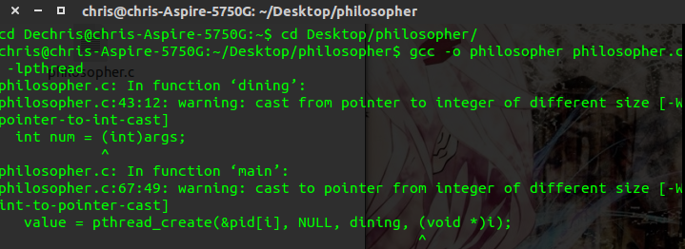
And the picture of the running part is as follows.
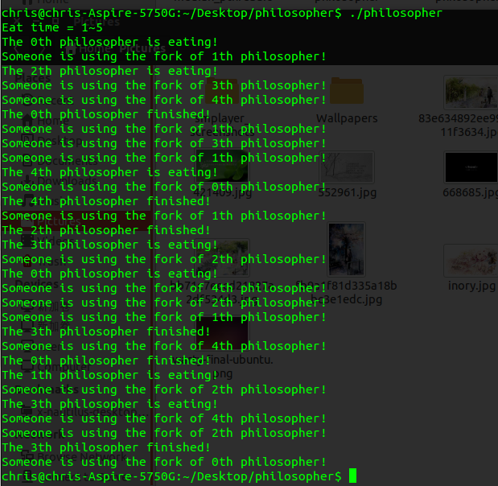
Codes are attached in the attachment.

P2
Median Filter

The method to solve this problem is the same as the last time I solve this in OpenMp, and there’re only a few modifications needed to achieve it in pthread, which you can easily see in the code.
In this problem, we need to get the median of the data in the window that we are processing to get rid of the noise. So to make the filter more practical, I need to read a file (of the pixel value of a certain image as a matrix) in the beginning of the code as the input. This can be processed by python or OpenCV, and since it’s not very related with the filter itself, so I just omitted the program to get pixel value in this report.
After get the data, to make it run in parallel, I divide the data in to multiple parts so that each thread can process almost the same number of data. For the part of data that can not be fully divided, you can see how I divide them in the code.
For each thread, I use a 5*5 window to process the median, and we can change the size of the window by modifying WINDOW_SIZE. In the beginning, I try to sort the data in the window using the bubble method. But with that method, we may do a lot of work that is not necessary, and that method can not run in parallel as a result of data dependency. So after discussing with my classmates, I find that we can get the median by counting how many points are that of a certain value. By adding the number of value, we can find the median easily.
In this program, I define the maximum value of a pixel to be 256, and the size of the image is 256*256, these parameters can all be changed in the definition part. In the end, the program will output the outcome value processed by median filter.
Codes are attached in the attachment.
Thank you.

